

An-Najah National University

Faculty of Engineering and Information Technology

Department of Computer Science



**Prepared by**: Anas Habash, Yasmeen Ghazi

**Supervised by**: Dr. Adnan Salman

*A project document submitted in partial fulfillment of the requirements for the Bachelor of Science degree in Computer Science.*

An-Najah National University

September, 2024

**Table of Contents**

Acknowledgment 2

Disclaimer 2

Abstract 2

Introduction 2

Overview 2

Key Features 2

Purpose of Forked Spider Web Company 2

**List of Figure**

# 

# Acknowledgment

First and foremost, we want to thank Dr. Adnan Salman for his help and support with our project. We also thank all of the academics in the Computer Science Department who helped us along the way. Moreover, we are immensely thankful to our families and friends for their unwavering support, and belief in our potential. Their contributions have been instrumental in the successful completion of this work.

## Disclaimer

This report was written by Anas Habash and Yasmeen Ghazi at the Computer Science Department, Faculty of Engineering and Information Technology, An-Najah National University. It has not been altered or corrected, other than editorial corrections, as a result of assessment and it may contain language as well as content errors. The views expressed in it together with any outcomes and recommendations are solely those of the student(s). An-Najah National University accepts no responsibility or liability for the consequences of this report being used for a purpose other than the purpose for which it was commissioned.

## Abstract

In a global supply chain, efficient distribution is crucial for meeting customer demands promptly. This document outlines a comprehensive workflow for a distribution company that bridges the gap between customers and manufacturers. The workflow involves receiving customer orders, creating orders for manufacturers, managing inventory in warehouses, and distributing goods to sub-distributors and end customers. The proposed system ensures high efficiency in managing orders, and inventory, enabling the company to deliver products swiftly and accurately.

## Introduction

Efficient distribution is a cornerstone of successful supply chain management, especially in a global marketplace where products are sourced from various countries. This document presents a detailed plan for a distribution company that handles orders from customers and coordinates with manufacturers to fulfill these orders. By creating a seamless process from order reception to final delivery, the company can enhance customer satisfaction and maintain a competitive edge. The proposed system emphasizes accurate inventory management, timely order fulfillment, and effective communication between all parties involved.

## Overview

The workflow for the distribution company involves several interconnected stages that ensure efficient handling of orders from customers to final delivery. Initially, the process begins when customers place orders for various products. These orders are meticulously documented and processed to initiate the subsequent steps. The company then creates separate purchase orders for the relevant manufacturers based on these customer orders, sending them to the factories that produce the requested products.

Upon receiving the products from the manufacturers, the company stores them in designated warehouses, with each shipment carefully documented and inventory levels updated accordingly. To maintain accurate stock levels and ensure product availability, the company employs a robust inventory management system. This system tracks stock levels, manages storage, and sets up notifications to alert managers when stock levels are low, thus preventing shortages.

Subsequently, sub-distributors place orders to purchase specific quantities of the stored products. The company processes these orders based on inventory availability and prepares the shipments. Finally, the goods are shipped to the end customers, with each shipment tracked to ensure timely delivery and maintain the condition of the products. This systematic approach not only streamlines operations but also enhances the overall efficiency of the distribution process, ensuring that customer needs are met swiftly and effectively.

## Key Features

1. **Order Management System**: Efficiently handles customer orders, ensuring accurate documentation and processing for timely fulfillment.
2. **Manufacturer Coordination**: Generates and manages purchase orders to various manufacturers based on customer demands, ensuring the correct products are sourced from the appropriate factories.
3. **Inventory Management**: Utilizes a robust inventory management system to track stock levels, manage storage, and ensure product availability. Alerts are set up to notify managers when stock levels are low.
4. **Warehouse Management:** Real-time inventory tracking and automated restocking ensure that stock levels are always optimal, reducing the risk of shortages and overstocking.
5. **User Reviews and Ratings:** Products are ranked based on user reviews, offering valuable insights from other businesses to help make informed purchasing decisions.
6. **Sales Predictions:** By utilizing machine learning, the platform predicts daily sales based on previous sales data, allowing businesses to plan and optimize their inventory and sales strategies.
7. **User-Friendly Interface:** The platform is designed with a simple and easy-to-use interface, ensuring that users can navigate and utilize its features without any hassle.
8. **Proximity-Based Warehouse Selection:** The platform uses an algorithm to determine the user's location and identifies the nearest warehouse, ensuring that products are shipped from the closest location to reduce delivery times and costs.
9. **Warehouse Manager Communication:** A built-in chat feature facilitates communication between warehouse managers and the company, streamlining coordination and addressing any issues promptly.

## Purpose of Forked Spider Web Company

Forked Spider Web Company is designed to achieve the following goals:

* Is to streamline and optimize the entire supply chain process, from receiving customer orders to delivering products to end customers. By efficiently managing orders, coordinating with manufacturers, and maintaining accurate inventory levels, the system ensures that customer demands are met promptly and accurately. This enhances customer satisfaction and loyalty, reduces operational inefficiencies, and minimizes the risk of stockouts or overstocking.
* Additionally, the system aims to improve communication and coordination between all parties involved, including customers, manufacturers, sub-distributors, and internal teams. Ultimately, this workflow system seeks to create a seamless and efficient distribution process that supports the company's growth and competitiveness in the market.

Product Scope:

The Forked Spider Web Company platform offers a range of features and functionalities tailored to meet the needs of B2B e-commerce in the electronics and computer components sector. The product scope includes:

* **User Interface:** A clean, intuitive, and user-friendly interface designed to facilitate seamless navigation and efficient use of the platform’s features.
* **Sales Prediction:** Machine learning algorithms that analyze historical sales data to forecast daily sales, aiding in accurate inventory planning and demand forecasting.
* **AI-Powered Chat Support:** An advanced AI-driven chat system that provides instant and accurate responses to user and manager queries, enhancing customer service and support.
* **Warehouse Management:** Support for managing multiple warehouses with dedicated user interfaces. Features include real-time inventory tracking, automated restocking alerts, and efficient communication between warehouse managers.
* **Inventory Tracking:** Real-time monitoring of stock levels across various warehouses to prevent shortages and overstock situations.
* **Analytics and Reporting:** Comprehensive tools for generating detailed reports and analyzing data on sales trends, inventory levels, and other key metrics to support strategic decision-making.
* **User, Warehouse Manager, and Admin Interfaces:** Specialized interfaces for different user roles, including a dedicated Admin Page for overseeing operations and platform performance.
* **Review and Rating System:** A system for ranking products based on user reviews, providing valuable insights from other businesses to aid in purchasing decisions.
* **Shortest Path Algorithm for Goods Transport:** An algorithm that optimizes the route for transporting goods between warehouses, ensuring efficient arrangement and minimizing congestion.

Definitions, acronyms, and abbreviations:

**Specific Requirements**

**Customer Interfaces:**

* **Home Page**: Users can easily place orders directly from the home page.
* **Product Categories**: Navigate through different categories of products available on the platform.
* **Products**: View a comprehensive list of all products offered by Forked Spider Web Company.
* **Product Search**: Allows users to search for specific products quickly and efficiently.
* **Product Return**: Allows customers to fill out a form and return products seamlessly.
* **My Account**: Users can update their profiles, including adding a profile picture and personal information.
* **Cart**: Users can view items added to their cart and proceed to checkout.
* **Add to Cart**: Easily add products to the cart for a streamlined shopping experience.
* **Product Rating**: Users can rate products based on their experience and satisfaction.
* **Top Selling Orders**: Displays the most popular orders based on sales.
* **Top Rated Products**: Highlights the highest-rated products as per customer reviews.
* **Lowest Priced Products**: Showcases the most affordable products available on the platform.

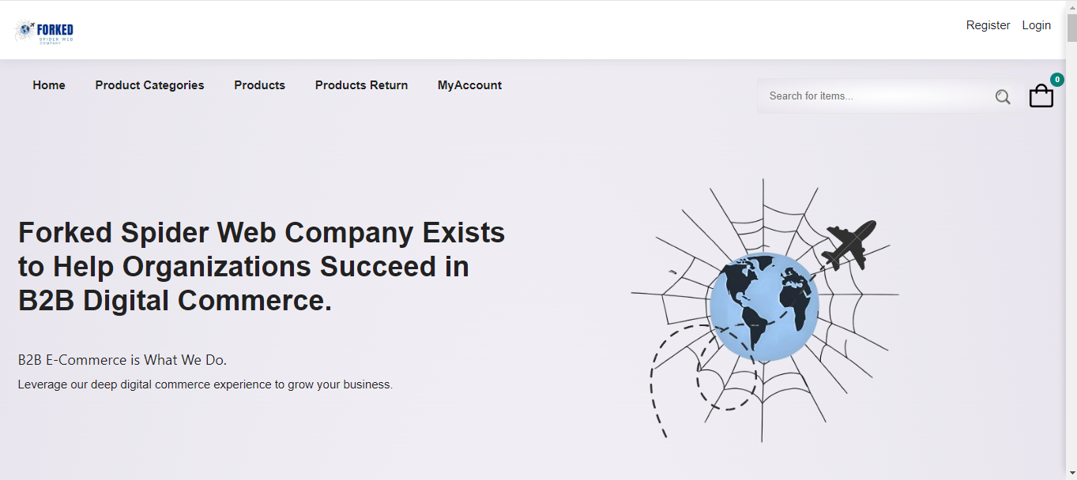

***Figure 1- Customer interface***

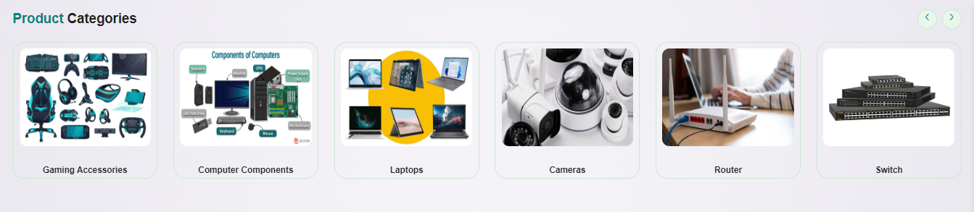

**Warehouse Manager Interface:**

* **Sales and Returns Overview**: View counts for Sales, Sales Returns, Manufacturing, Manufacturing Returns, and Delivery Orders.
* **Goods Receive and Transfer Overview**: Monitor Goods Receive, Transfer Out, and Transfer In activities.
* **Latest Activities**: Access the latest Sales, Manufacturing, Inventory Stock, and Inventory Transactions.
* **Order Management**:
* **Request Goods from Factories**: Place orders for goods from factories.
* **Receive Goods**: View and manage received goods (Goods Receive).
* **Return Goods to Factory**: Process returns to the factory (Manufacturing Return).
* **Warehouse Management**:
* **View Warehouses**: Access details of all current warehouses.
* **Add New Warehouses**: Create and manage new warehouse entries.
* **Assign Products to Warehouses**: Allocate products to specific warehouses.
* **Stock and Inventory Management**:
* **Transfer Products**: Move products from one warehouse to another.
* **Scrapping**: Manage the process of disposing of damaged or expired goods.
* **Stock Counts**: Perform and manage stock counts to maintain inventory accuracy.
* **Returns Management**:
* **View User Returns**: See the list of products returned by users.
* **Manufacturing Orders**:
* **Create Manufacturing Orders**: Generate manufacturing orders by reading 0files and storing the information in the database.
* **Chat with Admin**: Communicate directly with the admin via a chat feature to resolve any issues or coordinate activities.

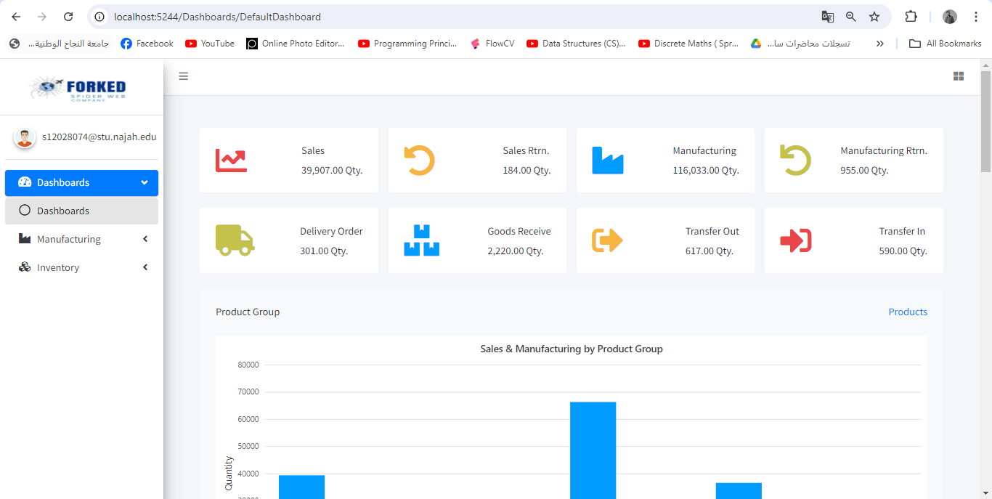

***Figure 2- Warehouse Manager interface***

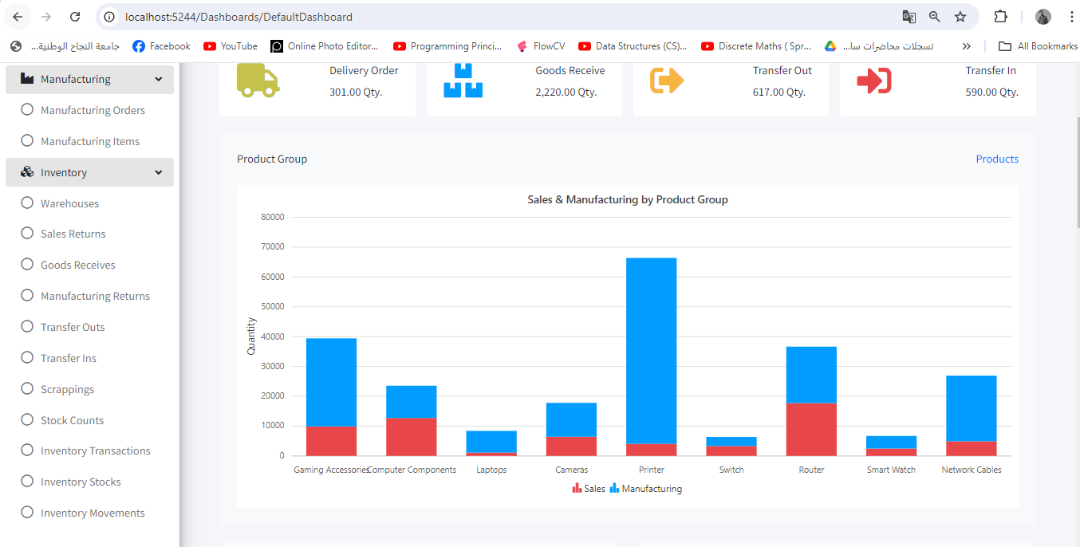

***Figure 3- Warehouse Manager interface***

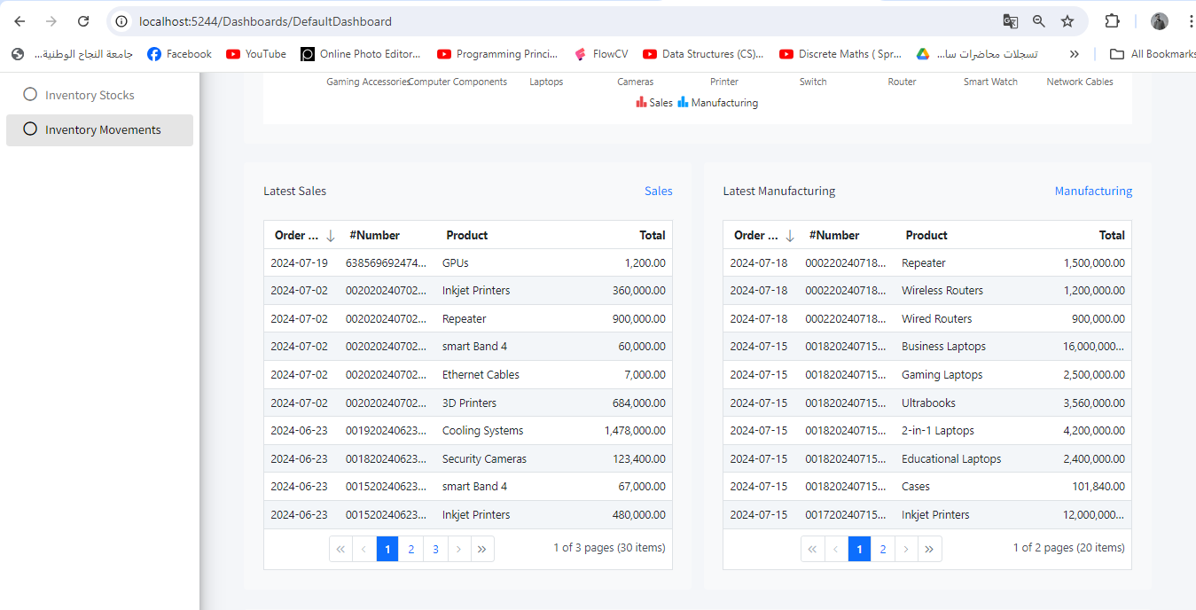

***Figure 4- Warehouse Manager interface***

**Admin Interface:**

The Admin Page includes all the functionalities available to the Warehouse Manager, with additional capabilities to manage the overall system and user roles.

**Additional Admin Features**:

* **Delivery Companies**: Add and manage delivery companies.
* **Company Information**: Edit and update the company's information.
* **Tax Management**: Add and manage taxes.
* **Role Management**:
  + **Add New Roles**: Create new user roles.
  + **Assign Roles**: Assign roles to users.
* **Log Sessions**: Monitor and manage user log sessions.
* **Error Tracking**: View and analyze errors faced by users to improve the system.
* **Log Analytics**: Perform log analytics to monitor system usage and performance.
* **Product Management**:
  + **Add Products**: Add new products to the inventory.
  + **Delivery Orders**: Create and manage delivery orders.
* **Factory Management**: Add and manage new factories.
* **Daily Sales Overview**: View sales data for each day to monitor performance and trends.
* **Order and Item Management**: Create orders and add items by reading files and storing the information in the database.

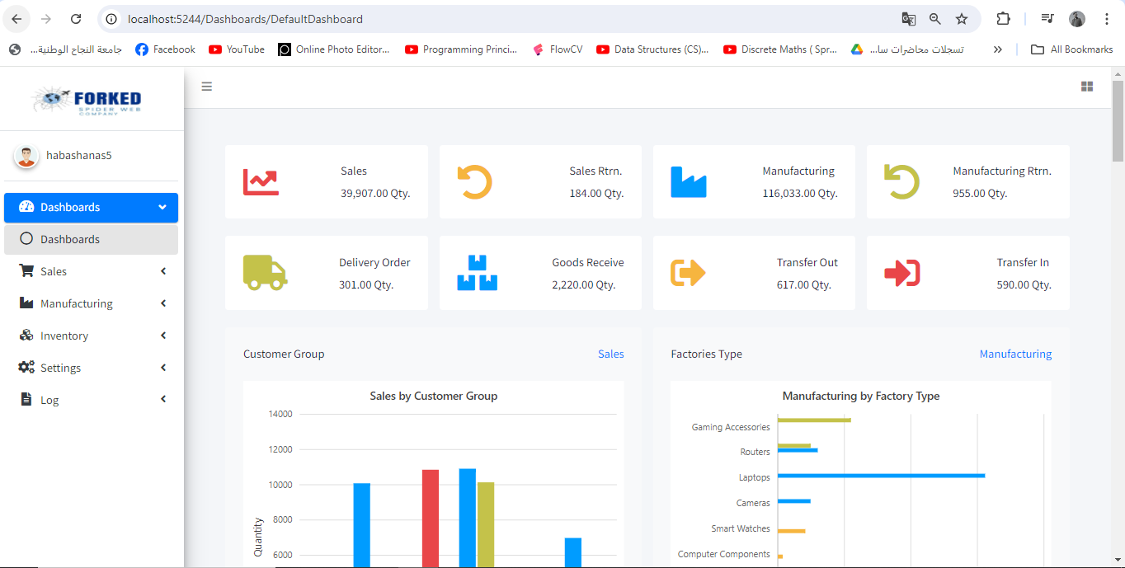 ***Figure 5- Admin interface***

**Software interfaces**

* **Internet browsers:**

Forked Spider web company is compatible with standard web browsers such as Google Chrome, Mozilla Firefox, Safari, and Microsoft Edge. Users can access the platform seamlessly through these browsers.

* **Security software:**

Forked Spider web company uses security software to ensure the confidentiality and integrity of user data. Encryption and secure communications standards are applied to protect user information

* **API between the backend and the database:**

**Establishing Connection:**

The backend uses an application programming interface (ApiOData) to interact with the database, allowing it to send queries to retrieve or update data in the database and allowing clients to perform operations such as pagination, filtering, searching, and sorting efficiently.

**Data updates:**

The backend can update data in the database through an application programming interface (API), allowing it to perform operations such as adding new warehouses, creating new orders, adding new delivery companies, and adding new taxes, among other functionalities.

**Communication interfaces**

Forked Spider web company communication interfaces play a crucial role in enabling seamless interactions between different components within the system:

**Functional requirement**

**Customer Registration**

Create an account for the customer by entering his basic information.

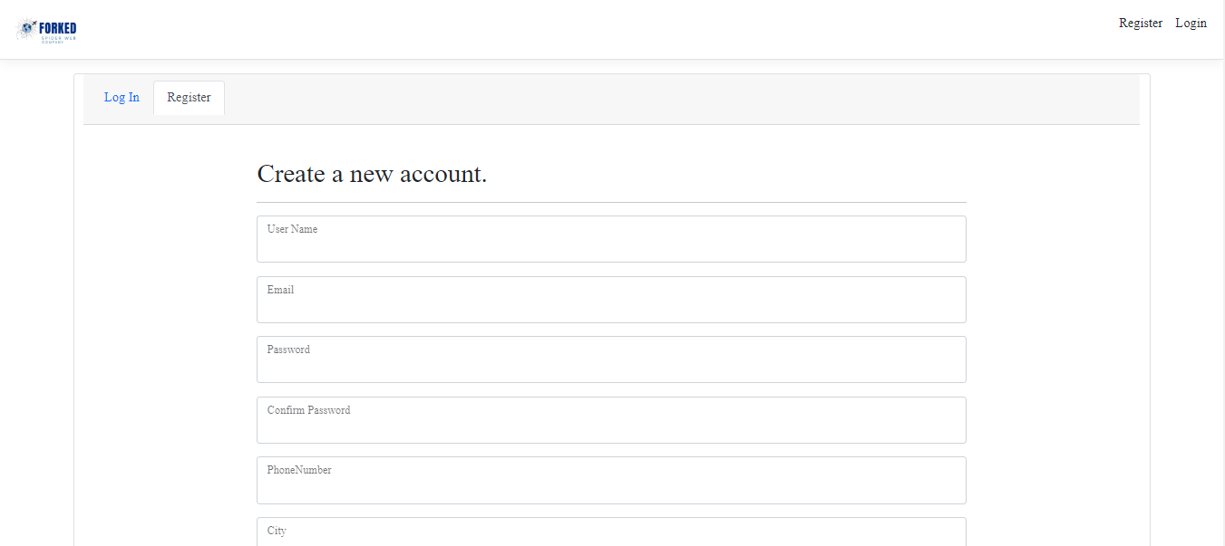

**Login**

Log in to the account for the customer, warehouse manager, and admin

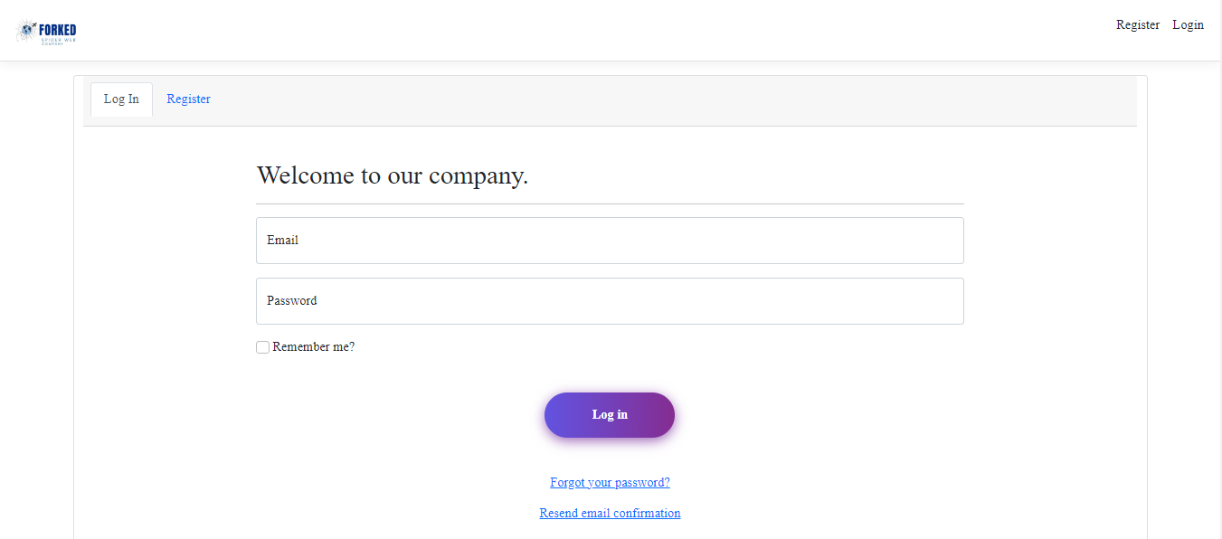

**Password Recovery**

Restore the account via email through the Forget Password option

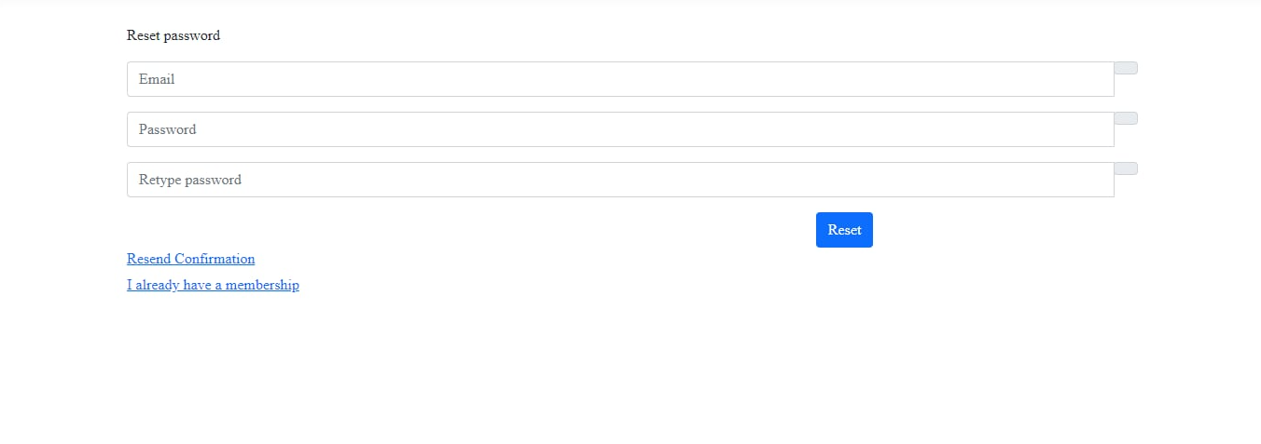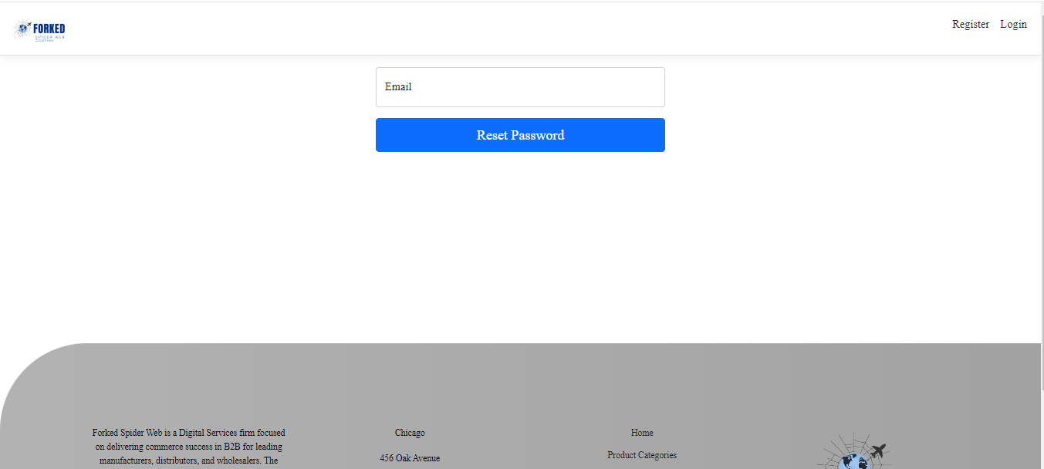

**Customer Profile Management**

Customer can edit, and manage their profiles, including personal information, Two Factor Authentication, and Change Password.

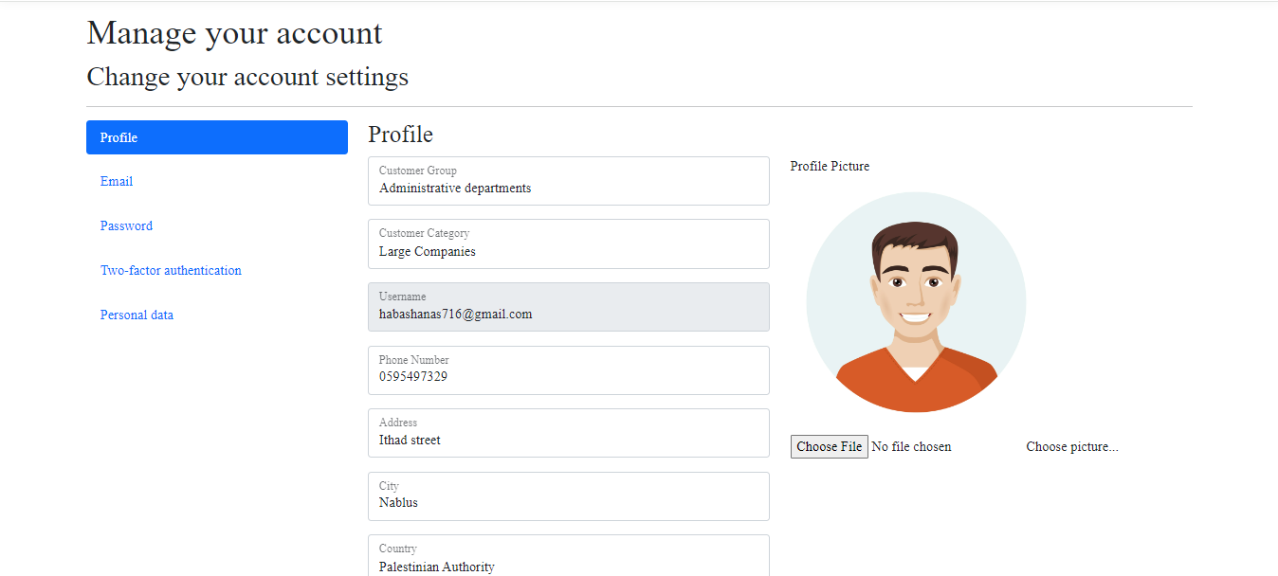

**Customer Product Return Form**

The customer can return the goods after receiving them and provide a reason for the return.

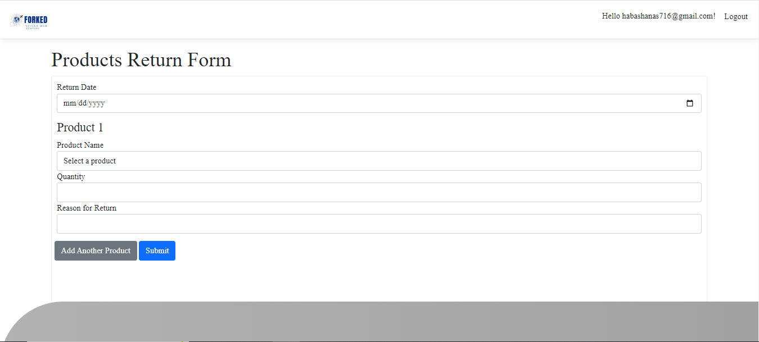

**Customer Rating**

The customer can rate the product by clicking the rating icon. The rating is calculated by incrementing the total number of ratings and updating the average rating based on the new input

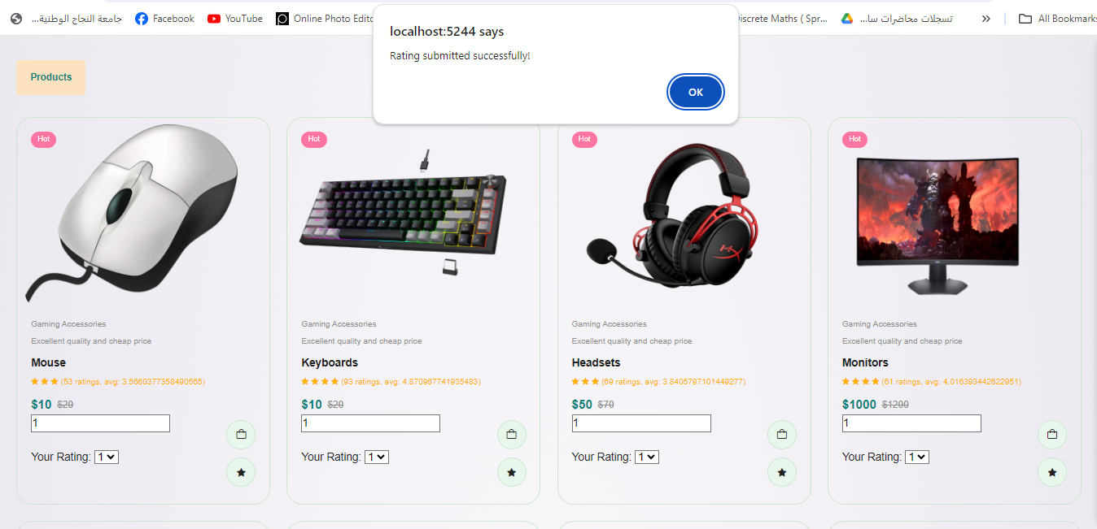

**Add to Cart and Order Confirmation**

The customer adds a product to the cart by clicking the “Add to Cart “ icon. After confirming the order, the customer will receive an email stating that their order will be delivered as soon as possible.

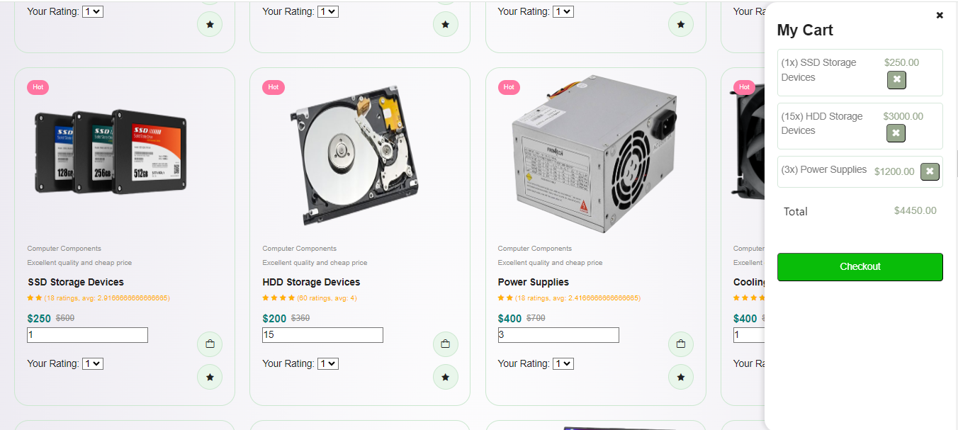

**Product Search Feature**

The customer can search for a specific product and the system will display the matching product result.





**Accounts management**

The admin's ability to see all accounts, roles and delete any of them

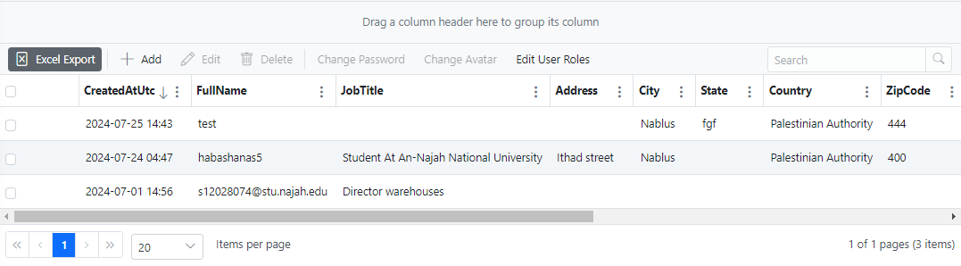

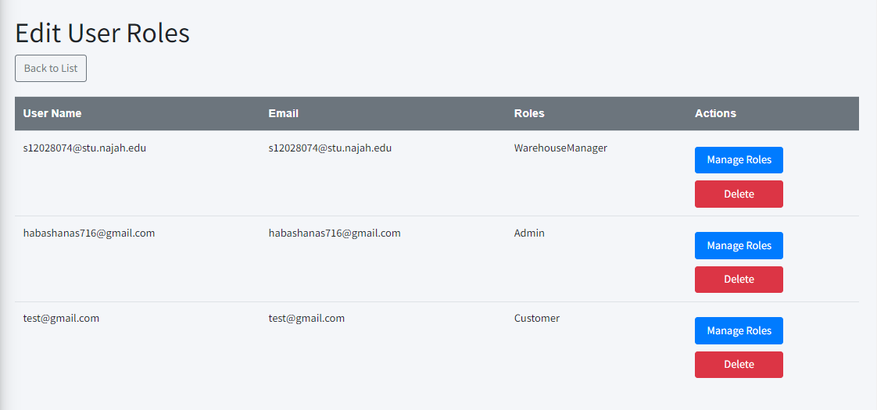

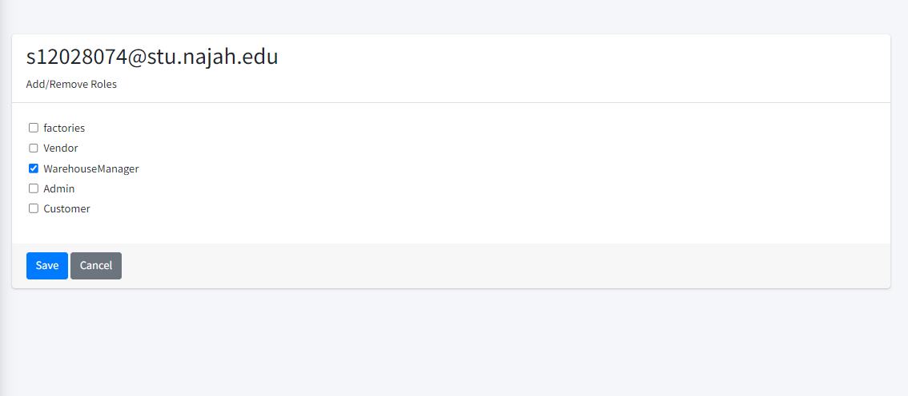

**Sales Order**

The Company will receive the sales order, which includes their customer information and order details.

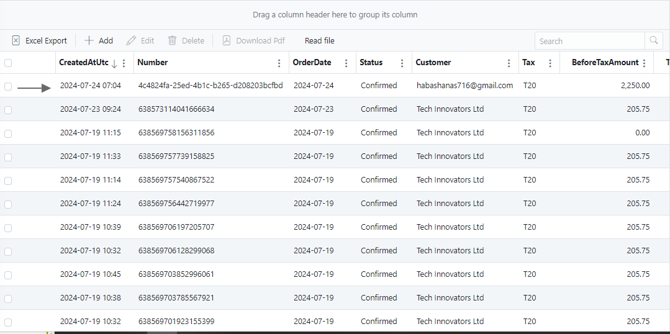

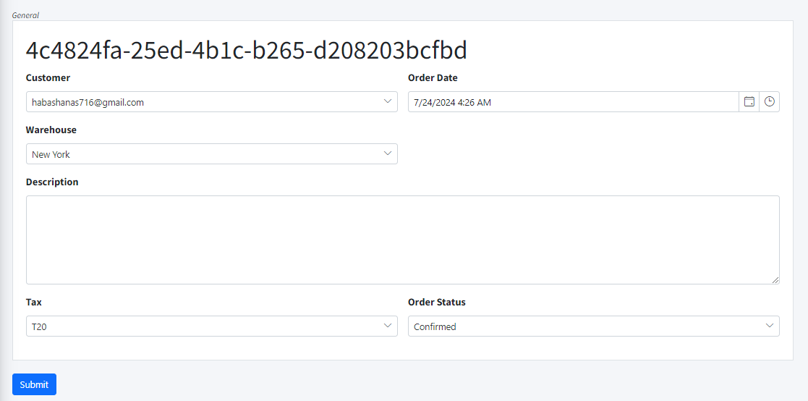

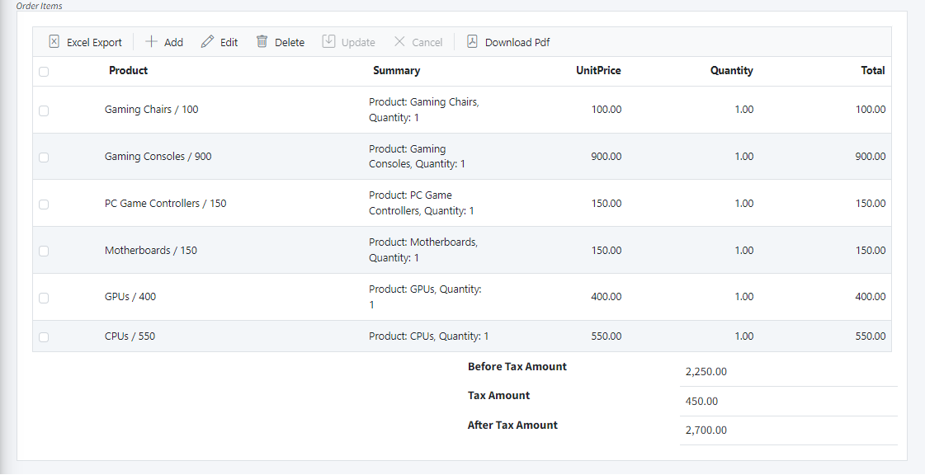

**Sales Order PDF View**

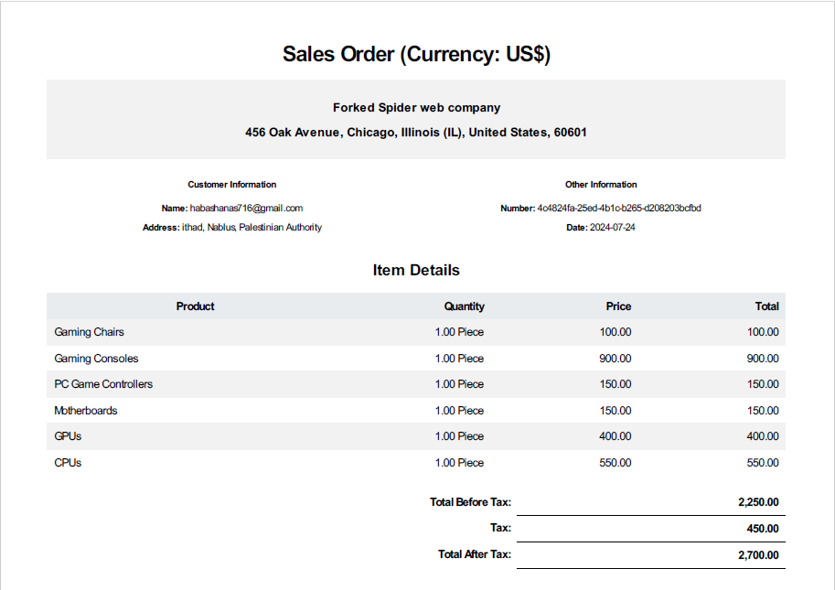The company can open their sales order and view the ordered products through a PDF file

**Export Orders to Excel**

The company can download all their orders into an Excel file.

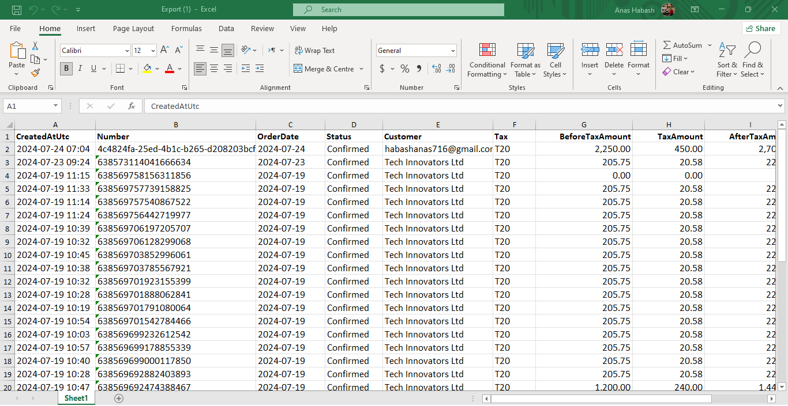

**Create Delivery Order Request**

Fill out the following details to create a delivery order: **sales order, delivery date, order status**, **and** **delivery company.**

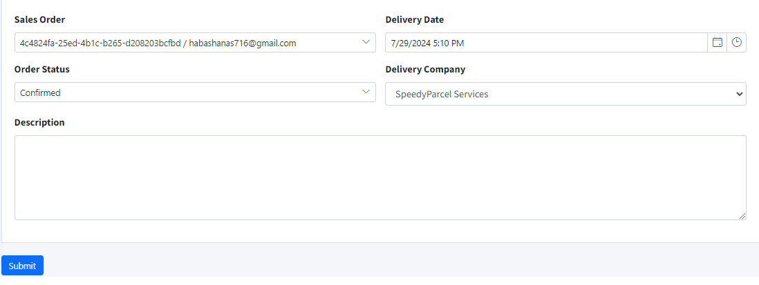

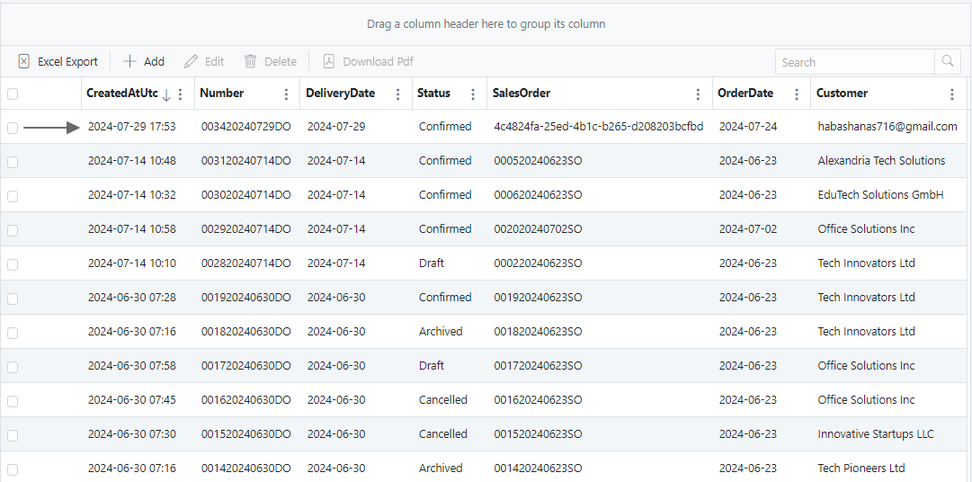

**Sales Return**

The customer can initiate a sales return after receiving orders

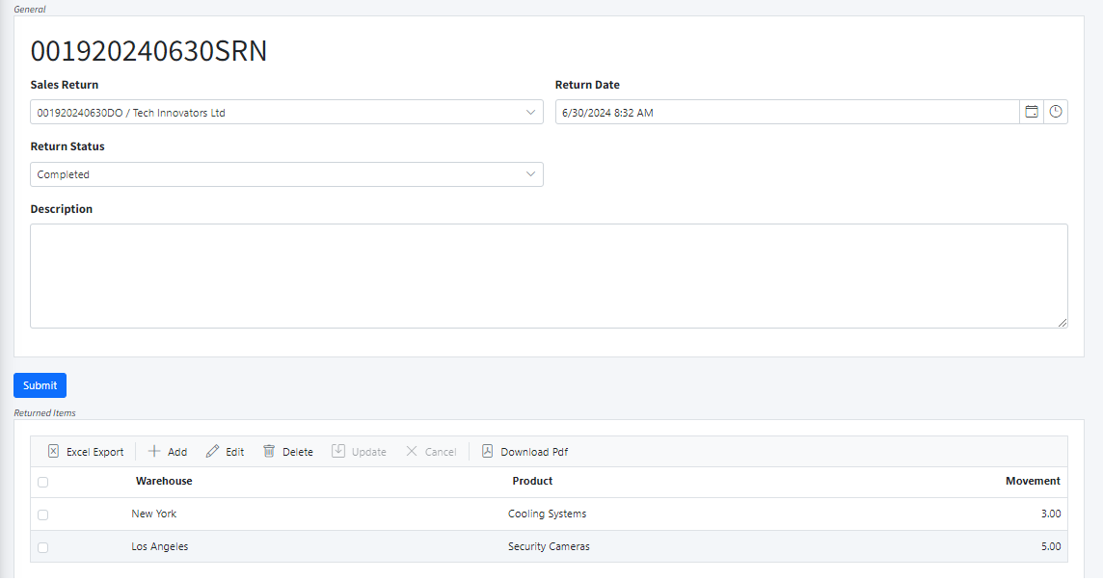

**Transfer Products Between Warehouses**

Specify the following details to transfer products between warehouses: **Source Warehouse, Destination Warehouse, Product Name, and Quantity.**

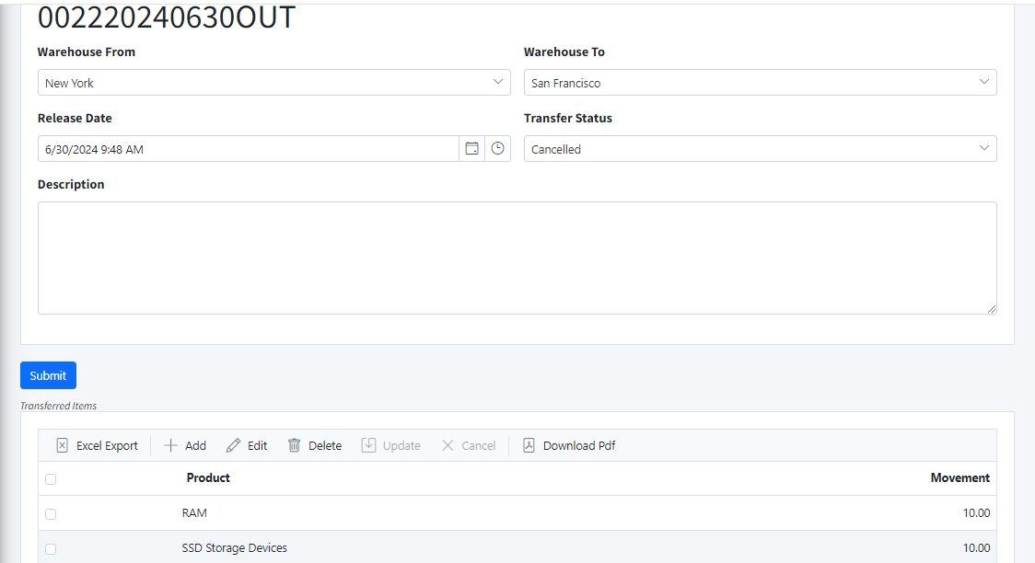

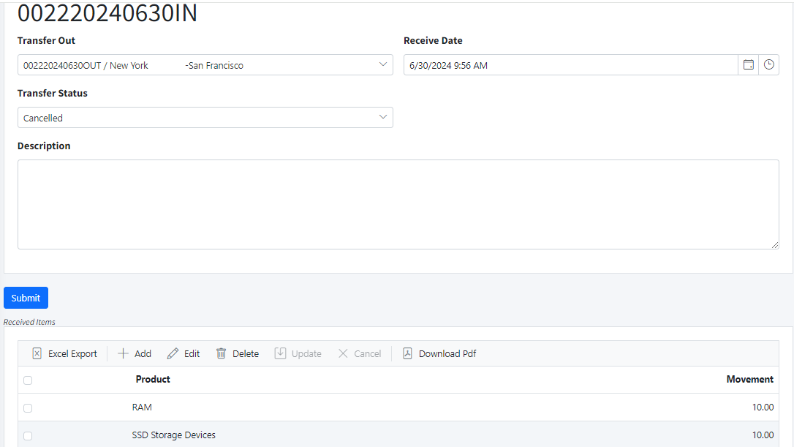

**Scrapping**

It is the warehouse manager’s responsibility to inspect the warehouses and dispose of any damaged goods.

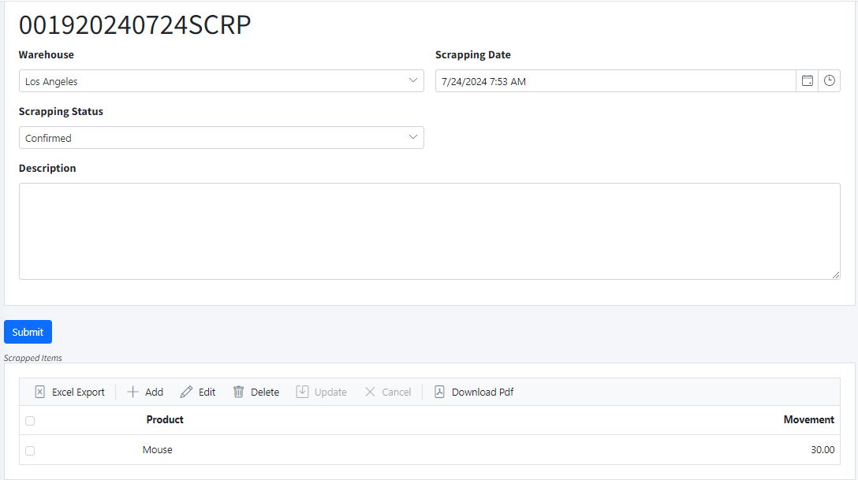

**Log Sessions**

Track user sessions by capturing the **username**, **IP address**, and the **action** performed.

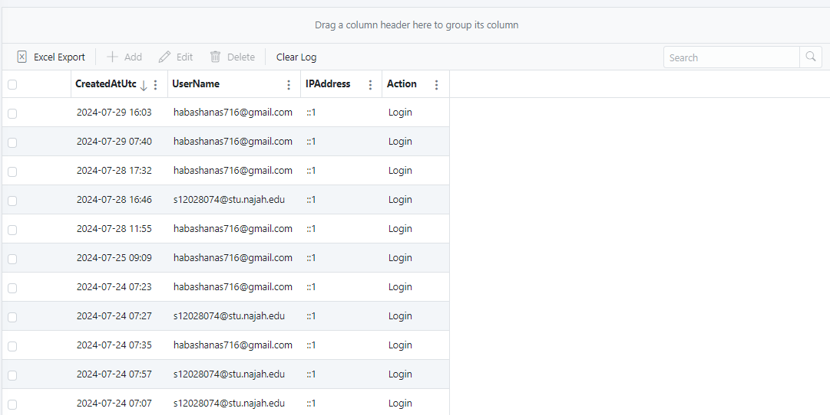

**Stock Counts**

It is the responsibility of the warehouse manager to conduct stock counts. This involves verifying the quantity of goods in the warehouses by comparing the system records with the actual stock on hand, and identifying any discrepancies such as excess or shortage.

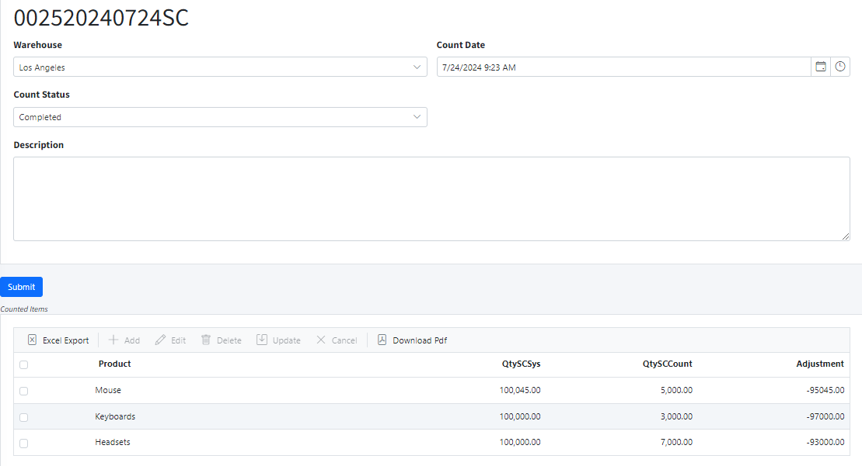**Log Analytics**

Analyze user interactions by logging the **username**, **URL**, **browser**, and **device**.

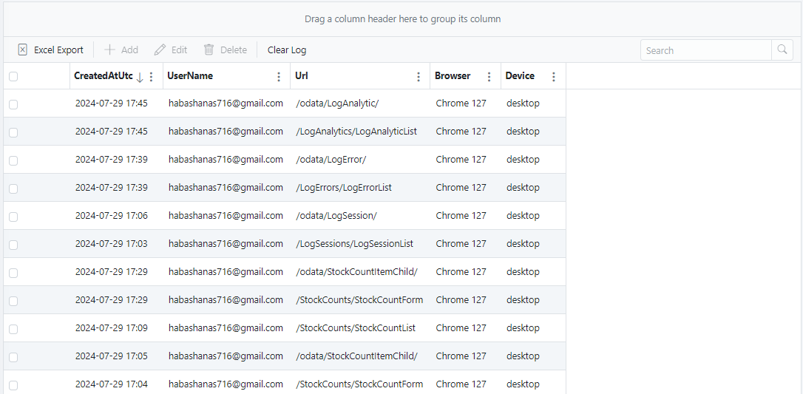

**Log Errors**

Monitor system errors using the **exception message** and **stack trace**. This helps identify and resolve issues that users may encounter while using the system.

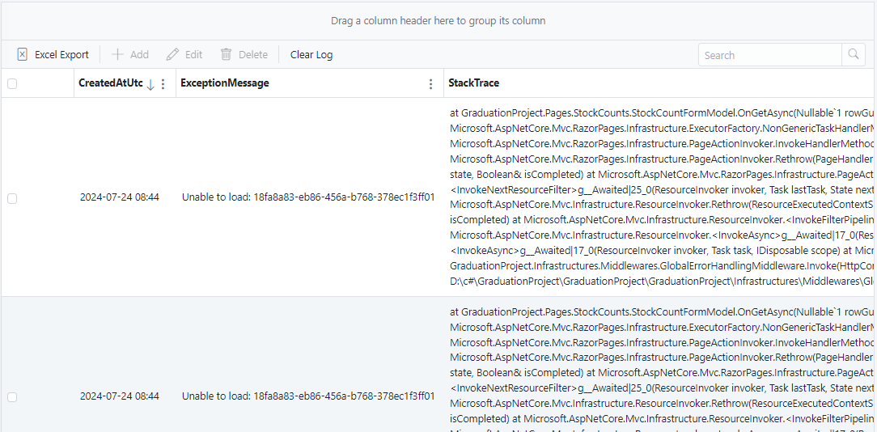

**Manufacturing Order**

It is the responsibility of the warehouse manager to place orders with the manufacturer for the required products.

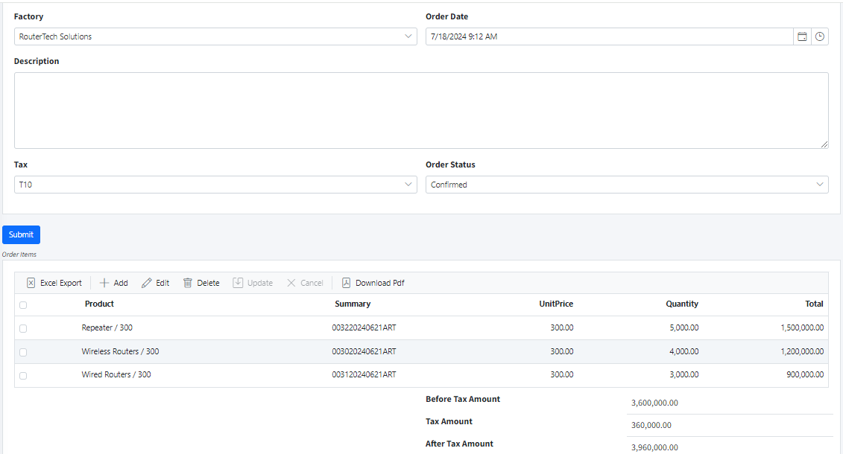

**Manufacturing Order PDF View**

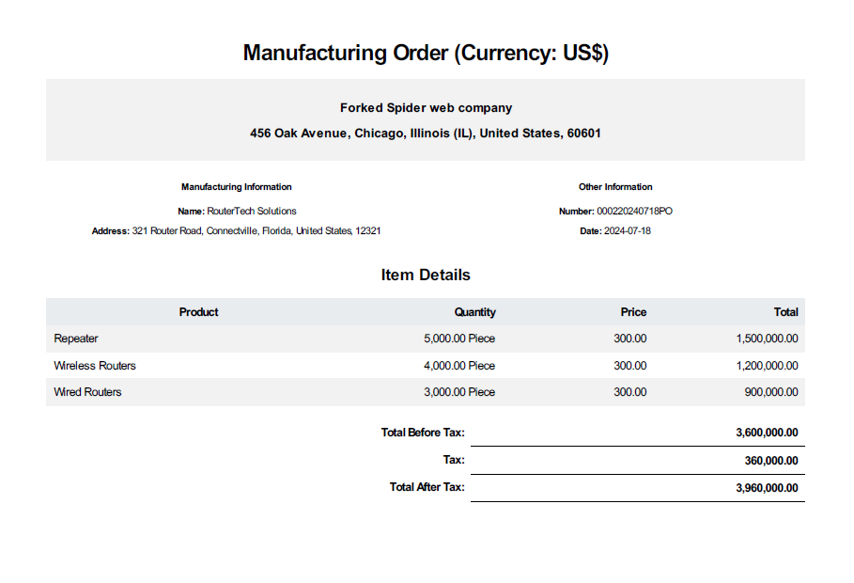

**Export Manufacturing Orders to Excel**

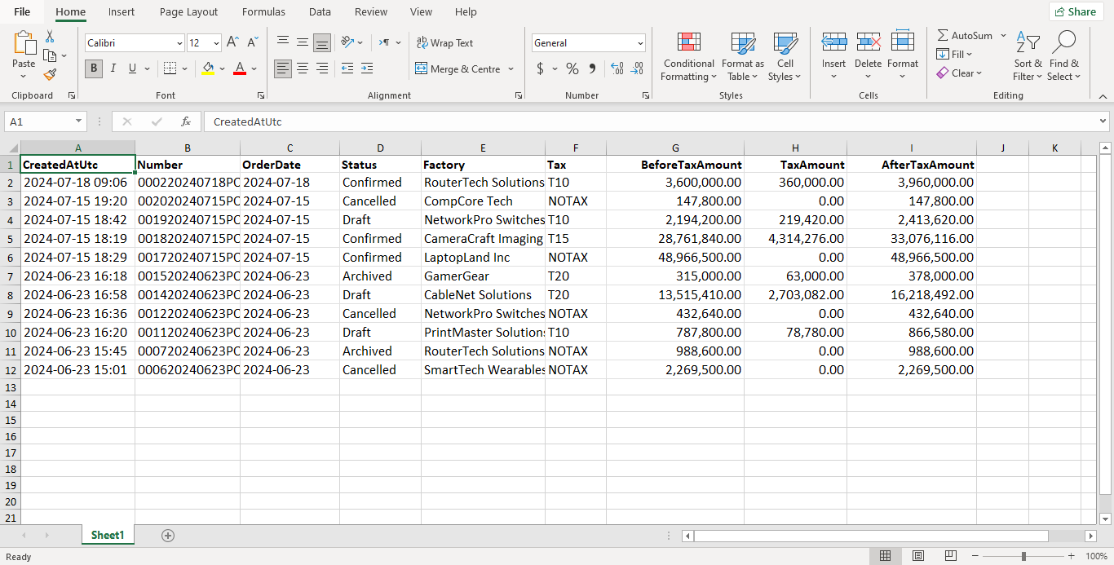

**Receive Products From Factory**

When receiving products from the factory, the warehouse manager is responsible for **Receiving**, and **Storage**:

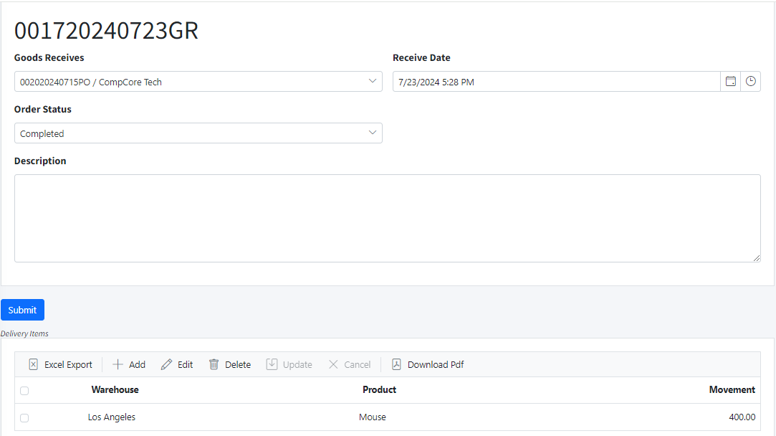

**Manufacturing Return Product**

the warehouse manager will:

* **Return Products**: Send the products back to the factory for reasons such as defects or incorrect items.
* **Reason for Return**: Provide a clear explanation for the return.

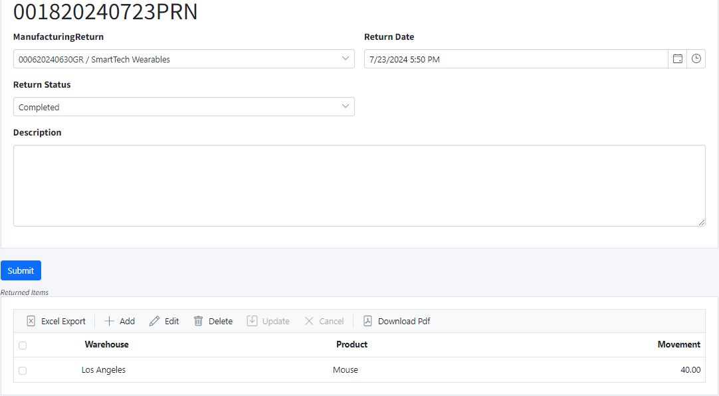

**Warehouse Manager – Company Chat System**

A chat system will be implemented to facilitate communication between the warehouse manager and the company. This system will include:

* **Real-Time Messaging**: Enable instant communication for inquiries, updates, and coordination.
* **Message History**: Keep a record of past conversations for reference.
* **Attachments**: Allow sharing of documents and images related to warehouse operations and orders

